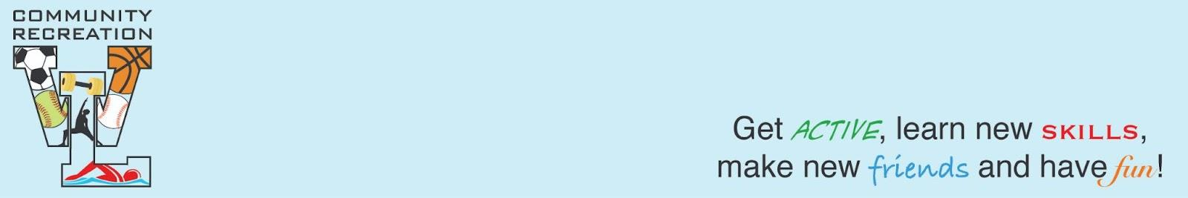
WLCR Code of Conduct for Parents and Athletes
Sideline Behavior/Parent’s Code of Conduct WL Recreation seeks to instill positive character-building traits in our communities’ youth through the demonstration of good sportsmanship, respect for others, responsibility, fairness, caring and good citizenship. We ask that parents and their guests attending our events help us by reflecting these character traits at games. When attending our events, I therefore agree:
• I will be a positive role model for my child and encourage sportsmanship by showing respect and courtesy, and by demonstrating positive support for all players, coaches, officials and spectators at every game, practice or other sporting event.
• I will refrain from coaching my child or other players during games and practices, unless I am one of the official coaches of the team.
• I will inform the coach of any physical disability or ailment that may affect the safety of my child or the safety of others.
• I will teach my child to play by the spirit of the rules and to resolve conflicts without resorting to hostility or violence.
• I will never ridicule or yell at my child or any other participant for making a mistake.
• I will respect the officials and their authority during games and will never question, discuss, or confront coaches or referees at the game field, and will take time to speak with coaches at an agreed upon time and place at least 24 hours after the game.
• I will not engage in any kind of unsportsmanlike conduct with any official, coach, player, or parent such as booing, taunting or using profane language or gestures.
• I will not encourage any behaviors or practices that would endanger the health and well-being of the athletes.
• I will demand that my child treat other players, coaches, officials and spectators with respect regardless of race, sex, or ability.
I also agree that if I fail to abide by the aforementioned rules and guidelines, I will be subject to disciplinary action that could include, but is not limited to the following:
• Verbal warning by official, head coach, and/or member of league organization
• Written warning
• Parental game suspension with written documentation of incident
• Potential impact to my son/daughter(s) playing time or team membership
Athletes’ Code of Conduct It is the view of WL Community Recreation that hard work, good sportsmanship and respect for others are key aspects of a successful competitive athlete. In this spirit, I recognize that I must conduct myself, both on and off the field, in a way that demonstrates respect for my coach, team, others, and me. I therefore resolve to:
• Accept accountability for my behavior and its outcomes, and recognize that poor behavior may result in dismissal from the team.
• Honor my obligations and promises to my coach and my team.
• Exercise self-control.
• Take pride in my team, our accomplishments, and myself but never at the expense of demeaning another person or group.
• Respect the efforts of others.
• Respect authority.
• Play by the spirit, not just the letter, of the rules of the game and the rules of life.
WLCR is dedicated to providing an inclusive environment with safe services, programs, and facilities that are welcoming to all individuals regardless of race, ethnicity, religion, spirituality, gender, gender identity/expression, age, sexual orientation, ability/disability, socioeconomic class, or national origin. We provide multiple workout areas and programs to address various skill, ability, and individual comfort levels. Members and program participants are expected to conduct themselves in accordance with Recreation Inclusive Commitment Standards.
Please join us in making Recreation a place for everyone.

